Please tick the related scope of your abstract:

Agronomy
Climate-smart agriculture
Controlled environment agriculture
Crop improvement for abiotic and biotic stresses
Emerging technologies (AI, robotics, digital agriculture)
Environmental science
Genetic engineering
Genetic resources and germplasm conservation
Genomic selection and marker-assisted breeding
Omics and bioinformatics
Plant physiology
Plant tissue culture and transformation
Plant protection
Precision farming
Regulatory, ethical, and commercial aspects
Soil science
Sustainable agriculture through biotechnology
Others

THE TITLE OF YOUR ARTICLE GOES HERE USING 14-POINT BOLD TIMES NEW ROMAN FONT WITH CENTRED ALIGNMENT

Author Name¹*, Author Name² 12-Pt_TNRoman Font, Author Name¹

¹School of Biological Sciences, Faculty of Applied Sciences, Universiti Teknologi MARA, Cawangan Negeri Sembilan, Kampus Kuala Pilah, 72000 Kuala Pilah, Negeri Sembilan, Malaysia
²School of Chemistry and Environment, Faculty of Applied Sciences, Universiti Teknologi MARA, Cawangan Negeri Sembilan, Kampus Kuala Pilah, 72000 Kuala Pilah, Negeri Sembilan, Malaysia The author affiliations should be written in n 12-font size Times New Roman font, italicised.

*Corresponding author: james.smith@gmail.com

ABSTRACT

Your abstract, in 12-font size Times New Roman font, having a maximum length of 250–350 words, goes here, written as a single-spaced paragraph with justified alignment. The abstract should include the background or introduction, objectives, methodology, key results, and a brief conclusion highlighting the significance of the study. The abstract for a research article should contain the background or introduction to the study, objectives or aims, methodology used, key results or findings, and a brief conclusion highlighting the significance or implications of the study. This template provides formatting guidelines for authors in the preparation of manuscript for publication. The authors must strictly follow the instructions given in this template for their manuscript preparation.

Keywords: abstract, maximum five, Times New Roman, 12-font size, and leave ONE blank line after abstract

INTRODUCTION

This template provides formatting guidelines for authors in the preparation of manuscript for publication. The authors must strictly follow the instructions given in this template for their manuscript preparation. The Introduction section should contain background about the research, problem statement, significance of the research and do mention the originality/novelty of your research. It is not advisable to use subsections such as ‘Literature review’, ‘Research Questions’ and etc.

MATERIALS AND METHODS

Your Subheading should be written in bold, Times New Roman, 12-font size, unindented, left justified

This template provides formatting guidelines for authors in the preparation of manuscript for publication. The authors must strictly follow the instructions given in this template for their manuscript preparation. All abbreviated forms should be spelled out for the first time. Use equation editor for all mathematics formulaes.

RESULT AND DISCUSSION

This template provides formatting guidelines for authors in the preparation of manuscript for publication. The authors must strictly follow the instructions given in this template for their manuscript preparation. All abbreviated forms should be spelled out for the first time. Use equation editor for all mathematical formulae. Table 1 and Figure 1 show

NOTE: Tables and figures should be cited in the text and must appear after their first citation within the text.

Table 1: Independent samples T-test between gender and readiness, perceptions and acceptance of GST

 | t | df | Mean Difference | Std. Error Difference
READY | 24.479 | 38 | 3.19658 | .21850
PERCEPT | 38.833 | 38 | 3.42735 | .16249
ACCEPT | 44.328 | 38 | 3.26496 | .12332
BEHAVIOUR | 45.542 | 38 | 3.22121 | .12211

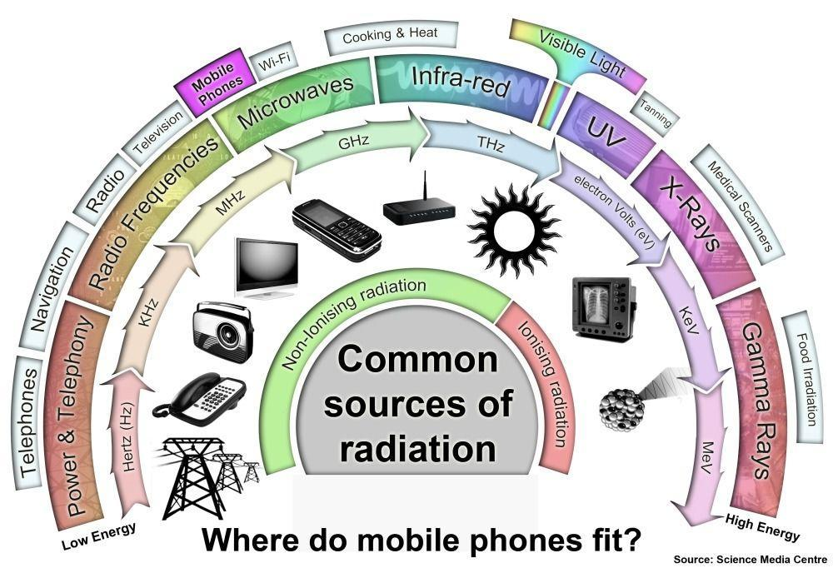
Figure 1. Common sources of radiation
CONCLUSION

This template provides formatting guidelines for authors in the preparation of manuscript for publication.

ACKNOWLEDGEMENT

The acknowledgement should be written in Times New Roman, 12-font size, justified alignment, and single spacing. This section should briefly mention any individuals, institutions, or organisations that contributed to the research but do not meet the criteria for authorship. If applicable, include appreciation for technical assistance, administrative support, or any form of non-financial contribution.

FUNDING

The funding statement should be written in Times New Roman, 12-font size, justified alignment, and single spacing. Clearly state the source(s) of financial support for the research. If no specific funding was received, write “This research received no external funding.”

DECLARATION OF COMPETING INTEREST

The declaration of competing interest should be written in Times New Roman, 12-font size, justified alignment, and single spacing. Authors must disclose any financial or personal relationships that could inappropriately influence their work. If there are no conflicts of interest, state: “The authors declare that they have no competing interests.”

REFERENCES

[References should be listed in alphabetical order, Times New Roman, font size 12, justified and single-spacing paragraph with format:
Journal – Authors. (Years). Title of paper. Journal title (spelled full), Volume (Issue number-optional), pages. DOI (optional) (Use: APA format system)

Eising, M., Cava, C. E., Salvatierra, R. V., Zarbin, A. J. G., & Roman, L. S. (2017). Doping effect on self-assembled films of polyaniline and carbon nanotube applied as ammonia gas sensor. Sensors and Actuators, B: Chemical, 245, 25–33. https://doi.org/10.1016/j.snb.2017.01.132

Sambasevam, K. P., Mohamad, S., & Phang, S.-W. (2015). Effect of dopant concentration on polyaniline for hydrazine detection. Materials Science in Semiconductor Processing, 33, 24–31. https://doi.org/10.1016/j.mssp.2015.01.008

Book – Authors, years, book title. publisher name, country. volume (issue number): pages.
Alley, E. R. (2007). Water quality control handbook. McGraw-Hill, New York: pp. 2 – 3.

Kleter, G. A., & Noordam, M. Y. (2015). Safety Assessment of Genetically Modified Foods. In Advances in Food Biotechnology. Chichester, UK: John Wiley & Sons Ltd.: pp. 27–36 https://doi.org/10.1002/9781118864463.ch03

Thesis – author, years, thesis title, degree, and university
Soukaina, R. (2015). Synthesis, characterization, and electrochemical properties of polyaniline thin films, Graduate Theses and Dissertations, University of South Florida

Mottaghitalab, V. (2006). Development and characterisation of polyaniline - carbon nanotube conducting composite fibres. Retrieved from http://ro.uow.edu.au/theses/491

Webpage – author or institution, year, title, link website, date access [The web url based references shouldn’t be more than 10% of total references]
Ministry of Health (2010). Effect of e-ciagrettes. http://www.e-cig.com.gov.my/list/. [Access online 24 August 2017].

